Phase 2

1. Describe the monitoring tool and provide two arguments to support your choice

The SolarWinds Netflow Traffic Analyzer is an open source monitoring tool that uses the NTA protocols to particularly provide broad range of monitoring functions that are very scalable towards the mode of the network-monitoring-tools

Argument 1: The software is totally free for the first one month and provides total service usage and monitoring to the network.

Argument 2: The software uses actual network operation to suggest methodologies used within the network.

2. Download and install the monitoring tool in your computer by giving the screenshot of his interface

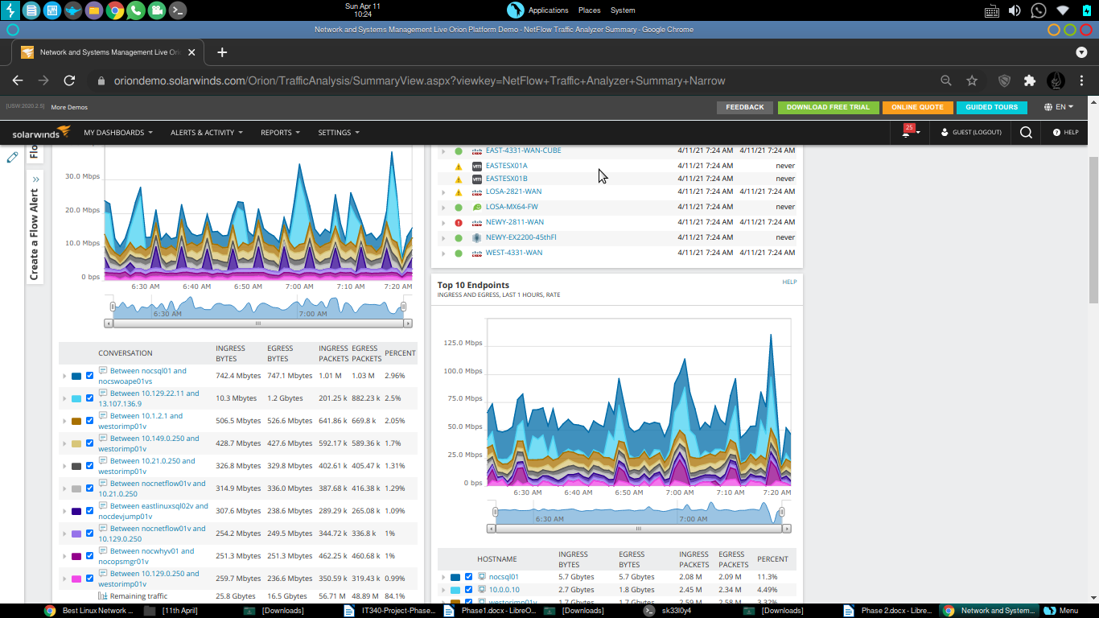

3. Configure the SNMP management tool by selecting the SNMP version, credentials, community name, context and so on by giving the screenshot for various selected parameters needed for configuration

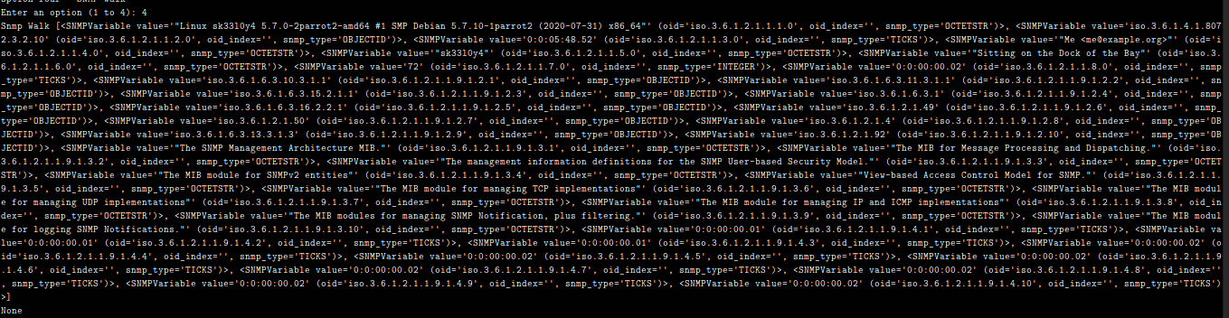

4. Make a discover of the network to know the connected devices in your network by providing the screenshot of the network map

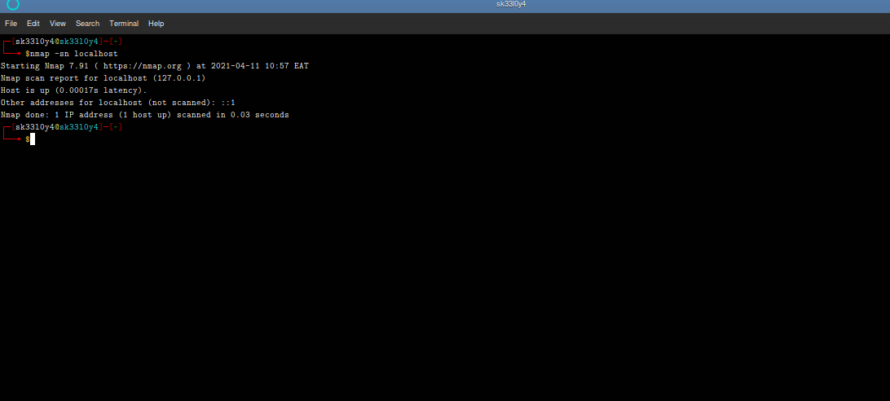

5. Describe three network analyzes provided by the monitoring tool by giving three screenshots and describe their network parameters. Use three different analyze categories like Performance/Top 10, Log/SNMP Trap and Tools/SNMP MIB Walker.

SNMPWalk For the various analyzes.
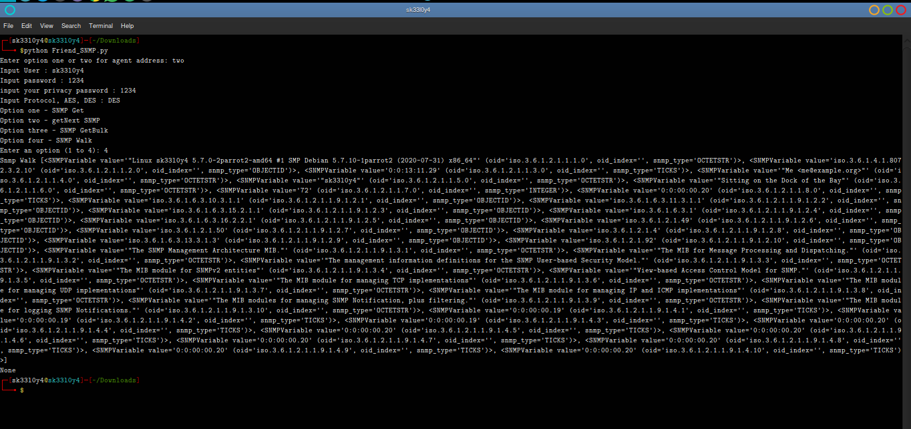
SNMPGet for MIB OID’s in the localhost
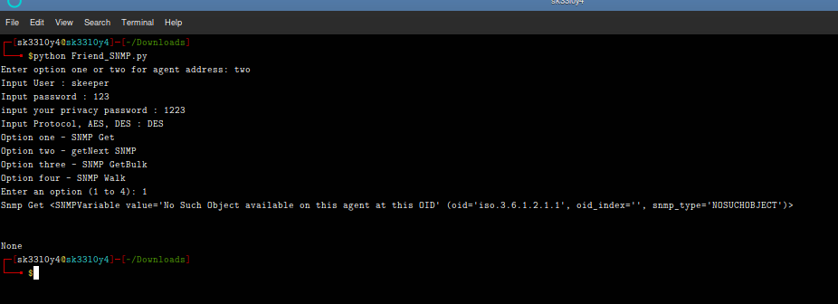
NextSNMP in data
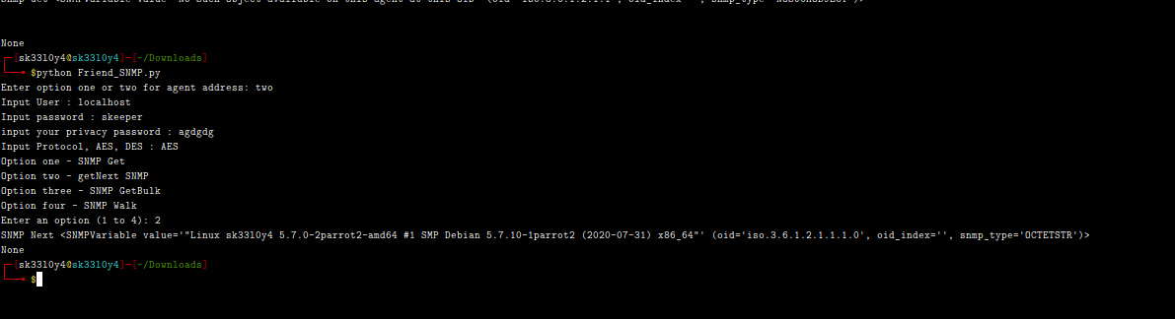
SNMPGetBulk for the various OID registered in the Local host.

